Getting Started …
Epi Info
Version 6.xx

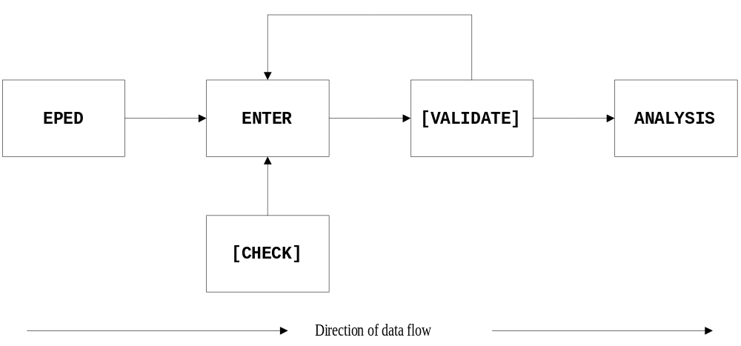

Mark Myatt


Getting Started …
Epi Info
Version 6.xx
Mark Myatt

This book is aimed at teaching readers with little or no experience of computers how to enter and analyze data in the shortest space of time.

The exercises are based on practical tasks needed by most users. The step-by-step instructions use little computer jargon and lead the reader from simple word processing through data entry and checking to data analysis.

Examples include:
Word Processing Survey Processing
Questionnaire Design Data Entry
Checking Data Editing Data
Data Analysis Statistics
Graphics Programming

The book offers a comprehensive introduction to survey processing using the Epi Info package.

Mark Myatt is a consultant epidemiologist who has been teaching the Epi Info package to students and professionals for the past seven years.

Brixton Books
ISBN 1-873937-01-6

£6.99

